

QUANTITATIVE FRAMEWORK FOR   
PARTNERSHIP EVALUATION

[ECL ESTIMATION & PROJECT FEASIBILITY]

Review Record

|  |  |  |  |  |
| --- | --- | --- | --- | --- |
| Approval Date | Version | Formulated/Revised Department | Reviewer | Key points of revision |
|  | V1.0 | KBANK HQ IM |  | First Version |

Table of Contents

1 Background 1

2 Input Data and Validation 3

2.1 Data Requirement 3

2.2 Data Format and Preliminary Data Validation 5

3 Methodology 11

3.1 Loan Channel’s Asset Quality 11

3.1.1 Asset Quality Trend 11

3.1.2 DPD flowrates and Probability of Default 16

3.1.3 Vintage (90+ DPD) 18

3.2 Financial Guarantor’s Ability to Guarantee 19

3.3 Project Evaluation (EBPT $-$ EL) 23

4 Reference 24

# Background

This document will outline the Quantitative Framework and Quantitative Criteria used for partnership evaluation.

In order to expand KBANK China retail lending businesses, it is necessary that we find the suitable business partners. The business model in our contention is the lending with fallback. The roles of the partners in such collaboration are two folds. The first role is “Loan Channel” (CH) in which the partner would serve as a customer (asset/loan) acquisition channels. Furthermore, in some business cases, a partner (can be another entity) also serves as a “Financial Guarantor” (FG) in which they provide assurance on the loan channel’s asset quality by providing a fallback mechanism for delinquent loans.

It is rightful that we established a framework determine to assess the quality and suitability of such partners. KBANK China has established two frameworks: Quantitative Evaluation and Qualitative Evaluation for the assessment of the said partnership. The two frameworks will be used collectively for the ultimate partnership selection. For business model involving guarantors/insurers, these analyses will be complemented by the traditional credit analysis and credit limit approval from the Credit Forum.

The first analysis within this quantitative framework is the Loan Channel’s Asset Quality Evaluation. We will utilize the monthly loan portfolio composition data (e.g. loan disbursement, outstanding, loan delinquency, etc.) along with the delinquency flow rates and portfolio vintage curves from loan channel partner. We have set up objective evaluation criteria to gauge whether the partner’s asset quality is acceptable corresponding to our business conditions. The outcome of this analysis are the estimation of the program’s probability of default of the assets and thus the suitability of the Loan Channel without asset quality fallback.

The second part of the analysis is the evaluation of the “Financial Guarantor”. It is essential to assess the guarantor’s ability to absorb and payback the delinquent loans. Failed buyback will ultimately affect the credit loss and thus the overall profitability of the program. We assess the probability that the guarantor would fail to buyback our delinquent assets using information from the financial statement namely the total amount of guarantee and the firm’s capital structure (asset and liability). The outcome of this analysis are the probability that the Financial Guarantor would fail to buyback the assets and thus the overall suitability of the Financial Guarantor.

The conceivable business scenarios are illustrated in the diagram below along with the conception of the Expected Credit Loss (ECL) for each business model.

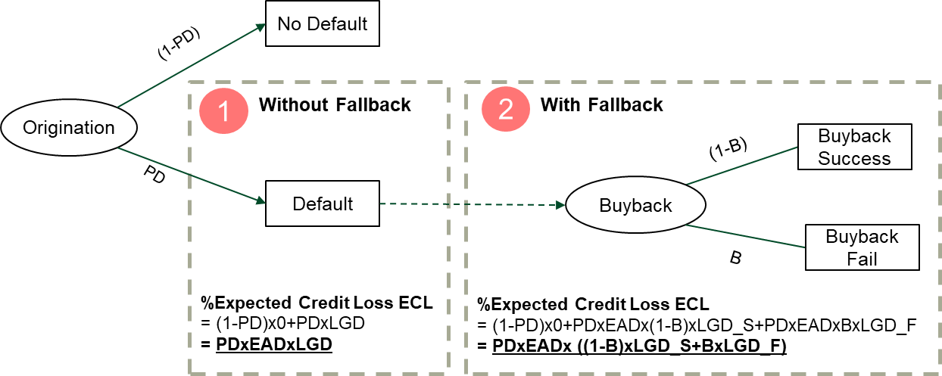

The ultimate expected credit loss within our conception is a function of the probability of default, exposure at default, loss given default and the probability failed buyback for business models with buyback.

Finally, the feasibility of a project / business model is measured by its expected risk-adjusted return. In our analysis we define such measure as the surplus of Expected Earnings Before Provision & Taxes (EBPT) over the Expected Credit Loss (ECL). This measurement will be used in the last evaluation of the exhaustive business model.

This document is sectioned as follow. Section 2 explains the data requirement and necessary data validation to ensure that data quality from the business partner is decent. In Section 3, we explain the framework and quantitative criteria in detail. Starting with the loan channel asset quality evaluation and then the evaluation of guarantee company's capability. Finally, we talk about the estimation of expected credit loss ECL and thus the overall profitability of this project.

# Input Data and Validation

## Data Requirement

To apply our framework, we required the following data from the Loan Channel

|  |  |  |  |
| --- | --- | --- | --- |
| **No.** | **Partner** | **Name** | **Detail** |
| 1 | Loan Channel | the monthly portfolio composition | Total loan disbursement, loan balance, number of loan disbursement, number of piece, total loan delinquency (e.g. DPD 1-30, 31-60,61-90,and etc.), number of loan delinquency(e.g. DPD 1-30, 31-60,61-90,and etc.),total write-off, number of write-off, total outstanding early paid-off, number of early paid-off. (At least 2 years of data). |
| 2 | Loan Channel | Monthly DPD bucket flow rates | the percentage of customer/outstanding who become increasingly delinquent. The monthly flow rate is essentially the percentage of customer who roll from 1-30 DPD bucket to the 31-60 DPD bucket, or from the 91-120 DPD bucket to the 121-150 bucket. (At least 2 years of data). |
| 3 | Loan Channel | Vintages | The performance of a portfolio in different periods of time after the loan was accepted (At least 2 years of data). |

Furthermore, for business model with fallback, we required the following data from the Financial Guarantor,

|  |  |  |  |
| --- | --- | --- | --- |
| **No.** | **Partner** | **Name** | **Detail** |
| 4 | Guarantee | Financial Statement | Summary financial report (past 3 years) |
| 5 | Guarantee | Guarantee detail | Total amount of guarantee, New amount of guarantee for the current year, amount of expired guarantee for current year, accumulated number of guarantee, number of guarantee in current year, number of expired guarantee in current year, amount of litigation preservation guarantee, number of litigation preservation guarantee (past 3 years) |

## Data Format and Preliminary Data Validation

|  |  |  |  |
| --- | --- | --- | --- |
| **No.** | **Partner** | **Name** | **Detail** |
| 1 | Loan Channel | the monthly portfolio composition | Total loan disbursement, loan balance, number of loan disbursement, number of piece, total loan delinquency (e.g. DPD 1-30, 31-60,61-90,and etc.), number of loan delinquency(e.g. DPD 1-30, 31-60,61-90,and etc.),total write-off, number of write-off, total outstanding early paid-off, number of early paid-off (At least 2 years of data) |

| **Item** | **Unit** | **Jan/2018** | **Feb/2018** | **Mar/2018** | **Apr/2018** | **May/2018** | **Jun/2018** |
| --- | --- | --- | --- | --- | --- | --- | --- |
| New Disbursement | pcs | 500 | 200 | 200 | 100 | 99 | 100 |
| Total number of accounts | pcs | 5,574 | 6,122 | 6,372 | 6,474 | 6,589 | 6,694 |
| Current Loan | pcs | 5,432 | 5,938 | 6, 181 | 6,227 | 6,344 | 6,430 |
| DPD1-30days | pcs | 83 | 109 | 101 | 147 | 121 | 130 |
| DPD31-60days | pcs | 22 | 35 | 39 | 32 | 47 | 38 |
| DPD61-90days | pcs | 14 | 13 | 22 | 23 | 20 | 29 |
| DPD91-120days | pcs | 11 | 10 | 9 | 19 | 17 | 17 |
| DPD121-150days | pcs | 6 | 8 | 7 | 9 | 18 | 10 |
| DPD151-180days | pcs | 4 | 5 | 6 | 8 | 12 | 28 |
| DPD180+days | pcs | 2 | 4 | 7 | 9 | 10 | 12 |
| Total Write-off Account (cumulative) | pcs | 7 | 9 | 10 | 13 | 19 | 24 |
| Write-off Account | pcs | 1 | 2 | 3 | 6 | 8 | 6 |
| Early Paid-off | pcs | 73 | 55 | 102 | 74 | 99 | 63 |
| New disbursement | Mil | 79.30 | 51.88 | 32.29 | 16.75 | 17.75 | 20.27 |
| Total amount of outstanding | Mil | 266.49 | 292.05 | 291.32 | 279.07 | 267.94 | 263.28 |
| Current Loan | Mil | 261.51 | 285.02 | 284.05 | 270.00 | 259.50 | 254.88 |
| DPD1-30days | Mil | 2.94 | 3.92 | 3.91 | 5.48 | 4.54 | 4.48 |
| DPD31-60days | Mil | 0.71 | 1.40 | 1.12 | 0.86 | 1.21 | 1.01 |
| DPD61-90days | Mil | 0.27 | 0.40 | 0.99 | 0.67 | 0.30 | 0.60 |
| DPD91-120days | Mil | 0.42 | 0.20 | 0.31 | 0.81 | 0.47 | 0.35 |
| DPD121-150days | Mil | 0.52 | 0.30 | 0.43 | 0.55 | 1.05 | 0.71 |
| DPD151-180days | Mil | 0.08 | 0.50 | 0.10 | 0.43 | 0.44 | 0.60 |
| DPD180+days | Mil | 0.04 | 0.31 | 0.41 | 0.34 | 0.51 | 0.70 |
| Write-off Amount | Mil | 0.03 | 0.35 | 0.05 | 0.28 | 0.20 | 0.34 |
| Total Write-off Amount (cumulative) | Mil | 0.20 | 0.40 | 0.45 | 0.69 | 0.84 | 1.14 |
| Recovery Amount | Mil | 0.14 | 0.00 | 0.04 | 0.05 | 0.04 | 0.04 |

Preliminary data validation is as follow,

1. The total amount of outstanding (orange color area) should equal to sum of the current loan and loan delinquency (green color area).
2. The amount of disbursement (yellow color area) should be consistent with the total amount of outstanding (green color area).
3. The total number of account (grey color area) would be equal to sum of current loan and loan delinquency (blue color area).
4. The accumulated write-off account and outstanding should not be drop during the time
5. The accumulated write-off account or amount should be consistent with the write-off account or amount in each month.
6. The accumulated disbursement account is relevant to the number of accounts in each month.

|  |  |  |  |
| --- | --- | --- | --- |
| **No.** | **Partner** | **Name** | **Detail** |
| 2 | Loan Channel | Monthly DPD bucket flow rates | the percentage of customer/outstanding who become increasingly delinquent. The monthly flow rate is essentially the percentage of customer who roll from 1-30 DPD bucket to the 31-60 DPD bucket, or from the 91-120 DPD bucket to the 121-150 bucket. (At least 2 years of data) |

|  |  |  |  |  |  |  |  |
| --- | --- | --- | --- | --- | --- | --- | --- |
| Flowrate | Dec/2018 | .. | .. | Jun/2020 |  | List | Definition |
| Current |  |  |  |  |  | C | Current loan |
| C-M1 |  |  |  |  |  | M1 | 1-30 days past due |
| M1-M2 |  |  |  |  |  | M2 | 31-60 days past due |
| M2-M3 |  |  |  |  |  | M3 | 61-90 days past due |
| M3-M4 |  |  |  |  |  | M4 | 91-120 days past due |
| M4-M5 |  |  |  |  |  | M5 | 121-150 days past due |
| M5-M6 |  |  |  |  |  | M6 | 151-180 days past due |
| M6-M7 |  |  |  |  |  |  |  |

|  |  |  |  |
| --- | --- | --- | --- |
| **No.** | **Partner** | **Name** | **Detail** |
| 3 | Loan Channel | Vintages | The performance of a portfolio in each month on book since loan disbursement date (At least 2 years of data). |

|  |  |  |  |  |  |  |  |  |
| --- | --- | --- | --- | --- | --- | --- | --- | --- |
| M1+ | | | |  | M3+ | | | |
| Opening month | Total disbursed amount for the current month | | |  | Opening month | Total disbursed amount for the current month | | |
| MOB 1 | MOB 2 | MOB.. |  | MOB 1 | MOB … | MOB … |
| Jul-17 |  |  |  |  | Jul-17 |  |  |  |
| Aug-17 |  |  |  |  | Aug-17 |  |  |  |
| Sep-17 |  |  |  |  | Sep-17 |  |  |  |
| Oct-17 |  |  |  |  | Oct-17 |  |  |  |
| Nov-17 |  |  |  |  | Nov-17 |  |  |  |
| Mar-18 |  |  |  |  | Mar-18 |  |  |  |
| Apr-18 |  |  |  |  | Apr-18 |  |  |  |
| .. |  |  |  |  | .. |  |  |  |
| July-20 |  |  |  |  | July-20 |  |  |  |

For evaluating the data quality

1. The vintage curve should be stable or increase only.
2. The vintage curve must be consistent with monthly loan delinquency.
3. The value must be in the percentage.

|  |  |  |  |
| --- | --- | --- | --- |
| **No.** | **Partner** | **Name** | **Detail** |
| 4 | Guarantee | Financial Statement | Summary Financial report (past 3 years) |

|  |  |  |  |  |  |  |  |  |  |
| --- | --- | --- | --- | --- | --- | --- | --- | --- | --- |
| **Balance Sheet** | | | |  | **Income Statement** | | | | |
| **Item (MRMB)** | **As of end 2018** | **As of end 2019** | **As of 29/02/2020** |  | **Item（MRMB）** | **As of end 2018** | **As of end 2019** | | **As of 29/02/2020** |
| **Total assets（总资产）** |  |  |  |  | **Total revenue** |  |  | |  |
| * Current assets |  |  |  |  | **Total expense** |  |  | |  |
| * + Cash |  |  |  |  | - Provision reserved |  |  | |  |
| * + Margin deposit |  |  |  |  | - Operation & management expense |  |  | |  |
| * + Account receivable |  |  |  |  | **Gross profit** |  |  | |  |
| * + Other account receivables |  |  |  |  | **Net profit** |  |  | |  |
| * Fixed assets |  |  |  |  |  |  | |
| **Total liability（总负债）** |  |  |  |  |  |  | |
| * Provision reserved for guaranty compensation（未到期责任准备） |  |  |  |  |  |  | |  | | |  |
| * Provision reserved for unexpired guarantee liability（担保赔偿准备） |  |  |  |  |  |  | |  | | |  |
| * Other account payables |  |  |  |  |  |  | |  | | |  |
| * Tax payable |  |  |  |  |  |  | |  | | |  |

|  |  |  |  |
| --- | --- | --- | --- |
| No. | Partner | Name | Detail |
| 5 | Guarantee | Guarantee detail | Total amount of guarantee, New amount of guarantee for the current year, amount of expired guarantee for current year, accumulated number of guarantee, number of guarantee in current year, number of expired guarantee in current year, amount of litigation preservation guarantee, number of litigation preservation guarantee (past 3 years). |

|  |  |  |  |  |
| --- | --- | --- | --- | --- |
| **Items （MRMB 百万元）** | **2017** | **2018** | **2019** | **2020** |
| Amount of guarantee for the current year (当年担保发生额) |  |  |  |  |
| * Loan Credit guarantee （融资性贷款担保） |  |  |  |  |
| * Litigation preservation guarantee （诉讼保全担保） |  |  |  |  |
| Amount of expired guarantee for the current year （当年应解保额） |  |  |  |  |
| Amount of outstanding guarantee as of end of period （期末担保余额） |  |  |  |  |
| Amount of outstanding guarantee liabilities as of end of period （期末担保责任余额） |  |  |  |  |
| * Loan Credit guarantee （融资性贷款担保） |  |  |  |  |
| * Litigation preservation guarantee （诉讼保全担保） |  |  |  |  |
| Number of guaranties as of end of period（期末在保户数） |  |  |  |  |
| * Loan Credit guarantee （融资性贷款担保） |  |  |  |  |
| * Litigation preservation guarantee （诉讼保全担保） |  |  |  |  |
| 当年担保代偿额 |  |  |  |  |
| 最大单笔担保责任余额 |  |  |  |  |
| 前五大客户担保责任余额 |  |  |  |  |

# Methodology

## Loan Channel’s Asset Quality

These sections breakdown the analyses to assess the viability of the loan channel business partner. This loan channel’s asset quality will reflect the ability of management in managing their credit portfolio. The portfolio vintages will also reveal the aggressiveness/conservativeness of their credit underwriting policy.

There are 3 aspects of portfolio quality that indicate the quality of the loan channel. The first part in 3.1.1, we consider the overall asset quality trend of the channel by looking at the time-series of portfolio composition i.e. proportion of delinquent loan to disbursement and etc. In part 3.1.2, we look at the delinquency flow rates i.e. the probability of moving from one DPD bucket to another. We estimated the asset’s probability of default based on this flow rates. In part 3.1.3, we look at the vintages of their portfolio to validate our understanding of the overall asset quality and probability of default estimate.

### Asset Quality Trend

The input data for doing the portfolio analysis is themonthly portfolio composition data from the Loan Channel. We look at the overall portfolio such as the disbursement, outstanding, current loan, loan delinquency, and etc to see the disbursement and asset quality trend.

|  |  |  |  |
| --- | --- | --- | --- |
| **Item** | **May-18** | **…** | **Jul-20** |
| Disbursement(Accumulate) | 1,017 MRMB | … | 1,115 MRMB |
| %DPD>30+ by disbursement | 2.50% | … | 4% |
| %NPL+ by disbursement | 1.78% | … | 2% |
| %ECL | 0.89% | … | 1.00% |

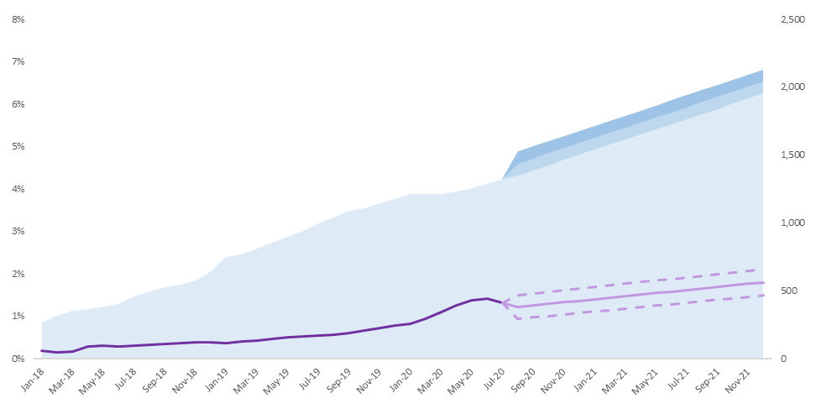

We then attempt to forecast the percentage of outstanding with 30+ DPD to disbursement to see the future loan delinquency trend. The methodology employed for forecasting the percentage of %EL is the exponential smoothing. The exponential smoothing is a time series forecast method by given the weighted average between the previous actual value and previous forecast value.

The equation for the exponential smoothing without seasonality is

|  |  |  |
| --- | --- | --- |
| $$F_{t}=$$ | $α y_{t-1}+(1-α)F_{t-1}$ |  |

where

$F_{t}$ is the forecasted value for the month $t$

$α$ is the smoothing factor or weight factor (0< α<1)

$y_{t-1}$ is the actual of value from the previous month

$F_{t-1}$ is the forecasted value from the previous month

The smoothing factor is automatically fitted by the excel function. For more detail please refer to [1] Microsoft Office Exponential Smoothing Documentation.

The output of the forecasting activity is as follow



Lower Confidence Bound

Upper Confidence Bound

Forecast

Actual %EL

We can set up criteria to monitor the business partner based on their asset quality trend. We currently assume that we do not have a matured retail credit risk management capability and that the portfolio quality of the partner would reflect to our own portfolio. We proposed two trigger points based on the profitability of each related party i.e.

1. Portfolio Expected Loss < Interest Rate Yield to Loan Channel and Financial Guarantor

If the portfolio expected loss is greater than the yield to Loan Channel and Financial Guarantor, the business model will be unprofitable to the group and it will be very likely that they will default on their credit guarantee.

This set up is assuming that both the Loan Channels and Financial Guarantor are the final receiver of the deteriorate assets.

1. Portfolio Expected Loss < Interest Rate Yield to KBANK

Our second trigger is that the portfolio expected loss must be lower than the yield to KBANK, the business model will be unprofitable to us.

Due to the fact that in most cases, interest rate yield to KBANK is greater than that of the loan channel & financial guarantor. We assumed that the Financial Guarantor would have already defaulted beyond the first trigger. This trigger is equivalent to the trigger point of business loss for KBANK without fallback. For simplicity, we neglect the cost of fund and other expenses at this moment.

We’d use the following trigger each of the business model

|  |  |  |  |
| --- | --- | --- | --- |
| Business Model | Without Fallback | With Fallback | |
| Yield |  | Yield to KBANK > Yield to CH&FG | Yield to KBANK  <= Yield to CH&FG |
| Trigger | 2 Only | 1 & 2 | 1 Only |

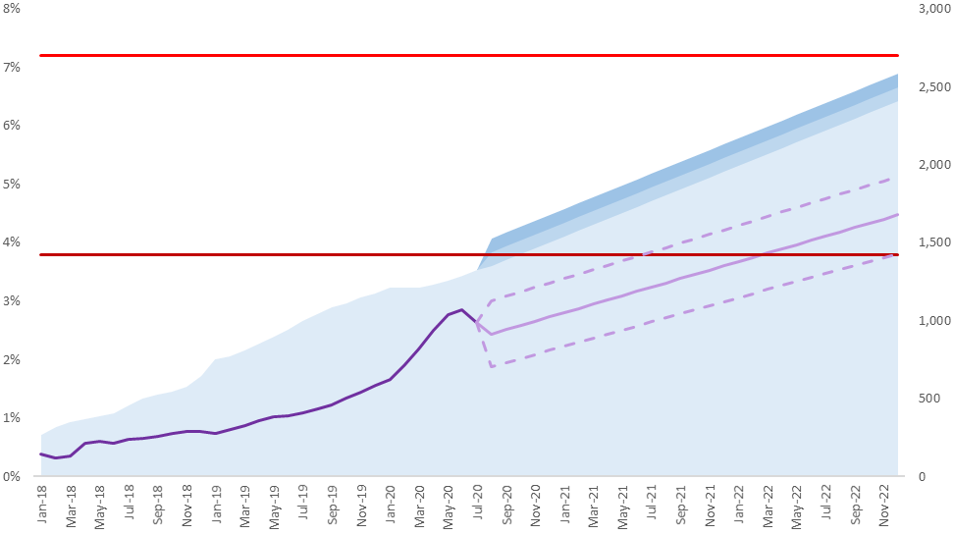

Current time

Yield to Loan Channel and Financial Guarantor

Yield to KBANK

|  |  |  |  |  |  |  |  |  |  |  |  |  |
| --- | --- | --- | --- | --- | --- | --- | --- | --- | --- | --- | --- | --- |
| **Criteria 1: Time to breach trigger**  It is obvious that the current asset quality of the Loan Channel shall not be worse than the above triggers. But what we are interested in are the future performances / asset quality of the partners. Thus, we formulated quantitative criteria based on the expected hitting time of the triggers. We are interested in the upper 95% confidence bound of the forecasted value. These criteria simply mean that we have a 95% confidence that the asset quality would not be worse than such trigger within a certain time period.  From the figure above $T_{1}$ is the period (month) that forecasted %ECL will hit Trigger 1 for the first time $T_{2}$ is the period (month) that forecasted %ECL will hit Trigger 2 for the first time  We initially set up the following criteria regarding the hitting time of each trigger   |  |  |  |  | | --- | --- | --- | --- | | **No.** | **Criteria** | **Meaning** | **Result** | | 1.1 | $$T_{1}≥6 months$$ | CH&FG will not default within 6 months | Pass/Fail | | 1.2 | $$T_{2}≥12 months$$ | KBANK can make the profit over 12 months | Pass/Fail | |

### DPD flowrates and Probability of Default

The probability of default (PD) is estimated by using the data monthly flow rate from the business partner. We predict PD in the next one year in the base and worst-case scenarios. The methodology for calculating PD consists of 2 parts. We first approximate the average 1-month DPD flow rate (DPD bucket transition) and formed a DPD transition matrix. And the second, we use the 1-month transition matrix to find the 12-month (1-year) PD.

If flow rate is not given by the Loan Channel, it will be calculated from the best approximation based on the given portfolio data. We use the loan outstanding in each bucket and we calculate the flow rate based on ratio of outstanding (B)/(A)

|  |  |  |  |
| --- | --- | --- | --- |
| **Item** | **Unit** | **Jan/2018** | **Feb/2018** |
| DPD31-60days | Mil | 0.71 (A) | 1.40 |
| DPD61-90days | Mil | 0.27 | 0.40 (B) |

$$Flowrate\left(31-60 to 61-90 DPD\right) =\frac{B}{A}$$

This conservatively assumes that all the customers could only roll forward or roll back to the current loan status only

We then look at the average flowrate across base and worst period of the loan channel operation. The periods for Base and Worst scenario is defined as follow

|  |  |
| --- | --- |
| Base | Worst |
| Subjective to  each Loan Channel | (NCP Covid-19) |

We construct a DPD state transition matrix using the average monthly flow rate as shown in the matrix below.

|  |  |  |  |  |  |  |  |
| --- | --- | --- | --- | --- | --- | --- | --- |
| Base Scenario | 1 Month | Repay | 0 DPD | 1-30 DPD | 31-60 DPD | 61-90 DPD | 90+ DPD |
| Repay | 100.0% | 0.0% | 0.0% | 0.0% | 0.0% | 0.0% |
| 0 DPD | 5.0% | 92.8% | 2.2% | 0.0% | 0.0% | 0.0% |
| 1-30 DPD | 0.0% | 25.2% | 50.4% | 24.4% | 0.0% | 0.0% |
| 31-60 DPD | 0.0% | 0.0% | 10.0% | 20.0% | 69.9% | 0.0% |
| 61-90 DPD | 0.0% | 0.0% | 0.0% | 6.7% | 13.3% | 80.0% |
| 90+ DPD | 0.0% | 0.0% | 0.0% | 0.0% | 0.0% | 100.0% |

To calculate the probability of default in the next 12 months, we assume that the DPD state transition is a Markov process. That is the current transition probability of the current state are independent to that of the past (historical transition path do not affect the transition rate). Furthermore, we assume that the transition rates are constant over the interested time period.

We simply multiply the transition matrix 12 times to get a yearly transition rate. The 1-year probability of default ($Pd$) output is illustrated in the last column of the matrix (red column).

|  |  |  |  |  |  |  |  |
| --- | --- | --- | --- | --- | --- | --- | --- |
| Base Scenario | 1 Year | Repay | 0 DPD | 1-30 DPD | 31-60 DPD | 61-90 DPD | 90+ DPD |
| Repay | 100.0% | 0.0% | 0.0% | 0.0% | 0.0% | 0.0% |
| 0 DPD | 43.0% | 47.1% | 2.5% | 0.9% | 0.8% | 5.7% |
| 1-30 DPD | 20.1% | 29.5% | 1.7% | 0.7% | 0.6% | 47.52% |
| 31-60 DPD | 2.4% | 4.3% | 0.3% | 0.1% | 0.1% | 92.8% |
| 61-90 DPD | 0.2% | 0.4% | 0.0% | 0.0% | 0.0% | 99.4% |
| 90+ DPD | 0.0% | 0.0% | 0.0% | 0.0% | 0.0% | 100.0% |

### Vintage (90+ DPD)

We analyze vintage by account opening month to see the performance in the subsequent month after account opening. The vintage curve can represent the credit quality of the borrowers in the portfolio and the effectiveness of the partner's approval criteria.

Besides, the loss rate from the vintage analysis can be used to verify the legitimacy of the portfolio data and flow rates data given by partners. The graph below is the example of vintage curve.

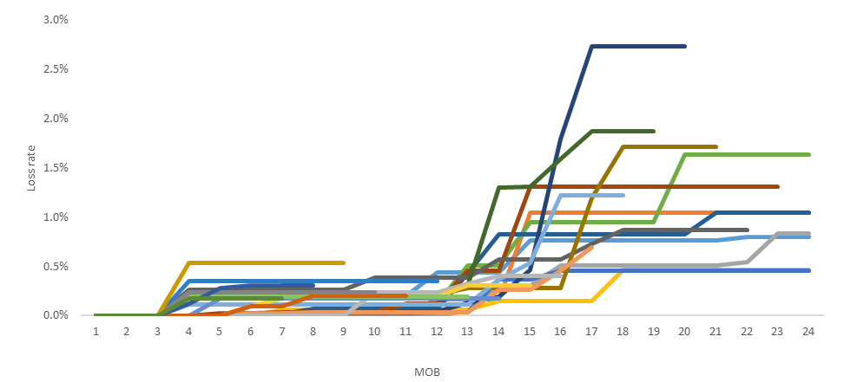

## Financial Guarantor’s Ability to Guarantee

For project with fallback, to estimate the final expected credit loss to KBANK, we need to determine the probability of the financial guarantor that would not be able to repay the guarantee claim.

The structure of this analysis is as illustrated below. Our partner FG is providing credit guarantee to a known amount of asset including loans from KBANK. We assume that the trigger point in which the Financial Guarantor would fail to buyback our asset is when their residual equity value is less than or equal to zero. That is their asset value is less than that of their debt.

Guarantee Firm

A = E + L

We’d need to estimate the residual equity value of the firm which is the leftover value of the firm plus all of the Expected Revenue (ER) and minus all of the Expected Payout (EP) from their guaranteed portfolio.

The residual equity value is defined as follow

|  |  |  |
| --- | --- | --- |
| $$RE =$$ | $$A – L + ∆E$$ |  |

$RE$ $RE$ is Residual equity value

$A$ is the total asset from financial statement

$L$ is the total liability from the financial statement

$∆E$ is the net expected gain / loss from operations

|  |  |  |
| --- | --- | --- |
| $$∆E =$$ | $$ER – EP$$ |  |
| $$ER=$$ | $$Premium Fee × Total Guaranteed Amount$$ |  |
| $$EP=$$ | $$X × Total Guaranteed Amount$$ |  |

$X$ is PD of the Guaranteed portfolio which in our analysis is a random variable

In this analysis, we make the following assumptions about the guarantee company

1. Financial Guarantor has a homogeneous asset pool that is identical to the asset provided by our Loan Channel (They only provide a guarantee for only 1 type of asset and from particular loan channels)
2. Cash flows other than the guarantee payout and revenue to the financial guarantor do not have a significant impact on the company's capital structure (balance sheet)
3. The default rate of financial guarantor’s portfolio $X$ is independent to our portfolio
4. The default rate $X$ is assumed to be log-normally distributed with the mean equals to the probability of default of our portfolio ($Pd$) and variance equals to variance of historical %30+ DPD to outstanding time series from the Loan Channel

Guarantee Firm

A = E + L

KBANK portfolio

Probability of Default equals to that of the channels

X ~ PD of Guaranteed portfolio

is a random variable

EP (Expected Payout) =

X * Total Guaranteed Amount

Assumption: X has its mean equals to our portfolio PD (Pd)

**Financial Guarantor Defaults when $RE≤0$**

|  |
| --- |
| **Criteria 2: Operating Loss for FG/CH**  The second criteria we set up here is to ensure the viability of the business model. We have to ensure the profitability of all related FG/CH in the model i.e. $$\%Group Fee (\%Guarantee Premium + \%Other fees to Guarantor \& Loan Channel) \\ > \%ECL (X×{LGD}_{product})$$ If the %EL is less than the %Group Fee, it means that our partners can retain some profits from doing this business.  A separate assumption can be made for the loss given default depending on the nature of the product. |

Furthermore, to estimate the probability that the financial guarantor would default on the claim compensation. We stressed probability of default $X$ to see all possible scenario of the residual equity value. We define the critical PD as the value of $X$ that produced zero residual equity value.

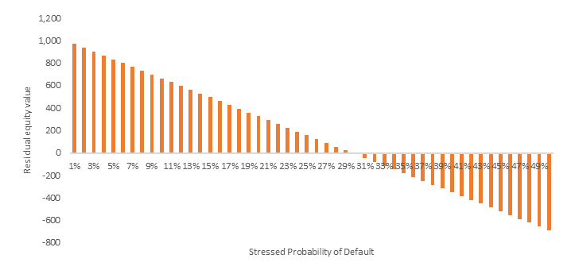

Critical PD

Residual Equity <0

Residual Equity >0

|  |
| --- |
| **Criteria 3: FG Loss Buffer**  The third criteria we set up here is to ensure that the FG still have some equity buffer to cover for the expected guarantee claim. The critical PD is the point that the residual equity equal to zero (Financial Guarantor may fail to buyback). Therefore, $X$ plus some conservatism buffer should be less than critical PD. $$Critical PD > X + Buffer 2\%$$ We initially set this value to 2% (subject to agreement from the MSG members) |

The last step is the estimation of the probability that guaranteed company is unable to pay back our claim ($B$). Since we assumed that $X$ is log-normally distributed with mean equals to $Pd$ and variance equals to the variance of historical %30+ DPD to outstanding time series from the Loan Channel

$$X \sim Lognormal\left(Pd, v\right)$$

We can find the probability that $X$ would be greater or lower than the Critical PD $P\left(X≤Critical PD\right)$ from the cumulative distribution function. This is essentially the probability of success buyback $\left(1-B\right)$ from the FG.

$$\left(1-B\right)=P\left(X≤Critical PD\right)$$

This process i.e. the probability mass function is shown as the blue curve and probability of failed buyback is illustrated in the figure below.

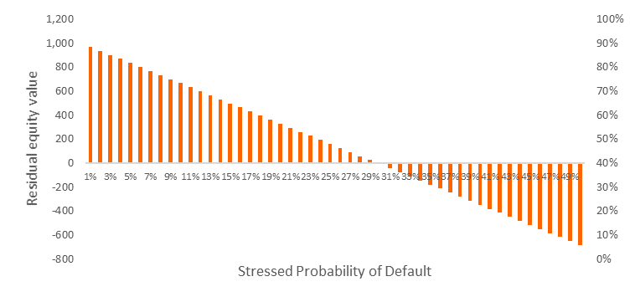

Failed Buyback

**B**



Success Buyback

1-**B**

## Project Evaluation (EBPT $-$ EL)

The project profitability is measured by the risk adjusted return defined as follow

$$\%EBPT-\%ECL$$

The Earning Before Provision and Taxes (%) is defined as follow

$$\%EBPT=\%Yield-\%MFTP-\%OPEX$$

As mentioned previously, there are two business 2 scenarios: lending with fallback and lending without the fallback. The Expected Capital Loss (%) is defined as follow

Without Fallback:

$$\%ECL=Pd*LGD_{product}$$

With Fallback:

$$\%ECL=Pd*\left[\left(1-B\right)*LGD_{success}+B*LGD_{failure}\right]$$

|  |
| --- |
| **Criteria 4:** Risk adjusted profitability is greater than zero  The project should yield the risk adjusted return that is more than zero i.e. $$\%EBPT-\%ECL>0$$ |

# Reference

[1] <https://support.microsoft.com/en-us/office/forecast-ets-stat-function-60f2ae14-d0cf-465e-9736-625ccaaa60b4>